**Deep Learning Track by Tugba Eraslanoglu**

Finding Protests in Berlin using Zero-Shot Classification

**Introduction**

It is essential for social consciousness and activism in Berlin, a dynamic city, to comprehend and monitor protests.

There may be limitations to conventional techniques for recognizing protests. There is a more thorough and effective method available when using Natural Language Processing (NLP).

Using the "facebook/bart-large-mnli" approach, this talk investigates how to analyze protest summaries and descriptions in Berlin.

**Methodology**

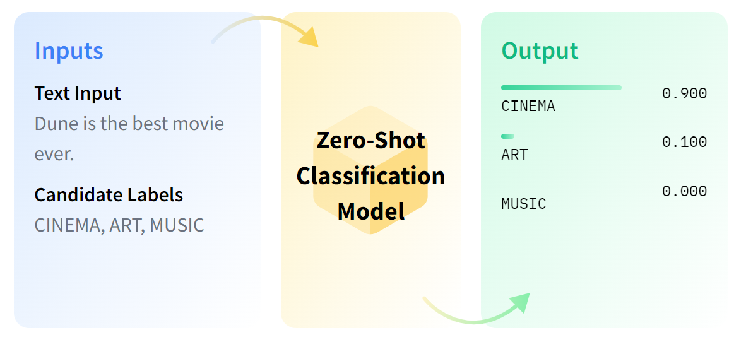

Utilized zero-shot classification algorithm with the "facebook/bart-large-mnli" model.

Zero-shot classification allows the model to classify protest descriptions without explicit training on protest-related data.

A CSV table containing protest descriptions and summaries from ACLED by provided newspaper sources was used as a dataset.

The model analyzed each description to determine the aim of the protest, providing valuable insights into the nature of protests in Berlin.

**Example**

Description: *People, including members of BUND, Campact, SPD, and The Greens, protested in the government district in Berlin - Mitte to call on authorities to ban harmful pesticides, protect bees, and give more support to farmers.*

Target labels: Agriculture, Solidarity, Conflict, Against Environment, and so on.

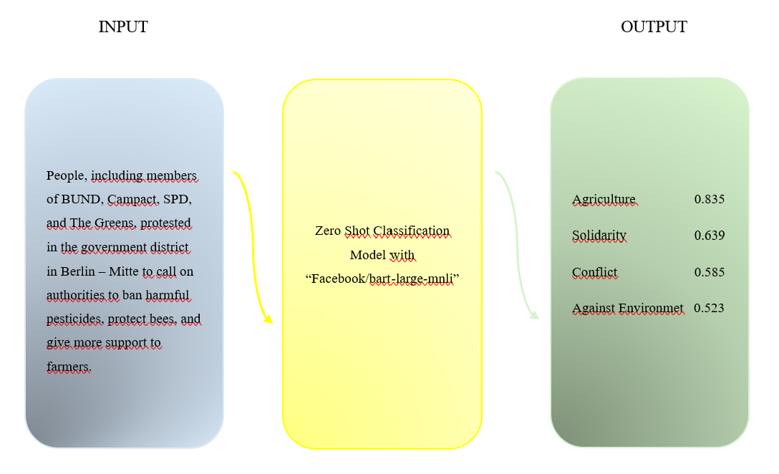

Predicted category: Agriculture with 84%.

**Results**

Recognized a number of protest genres, such as activism related to the conflict, climate change, coronavirus and solidarity.

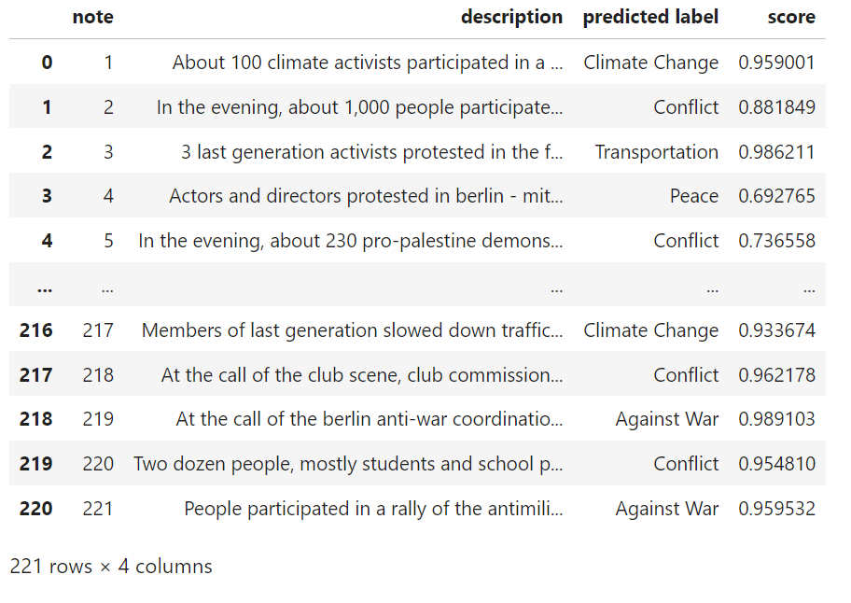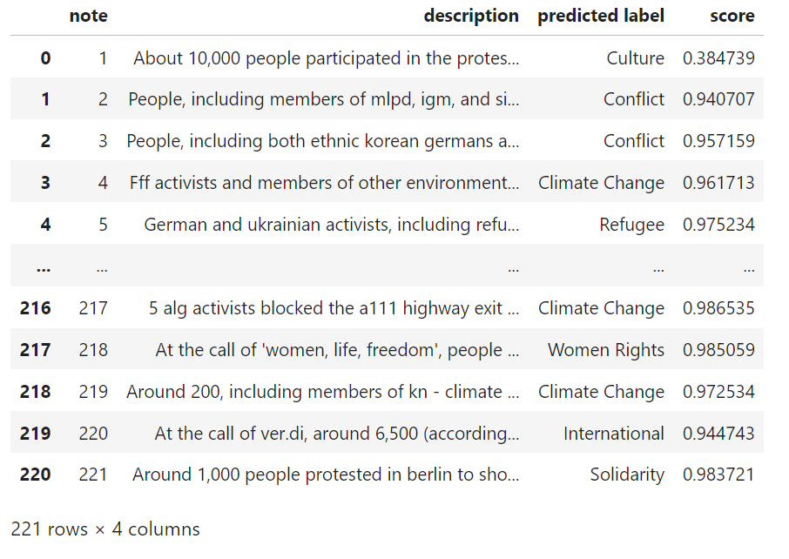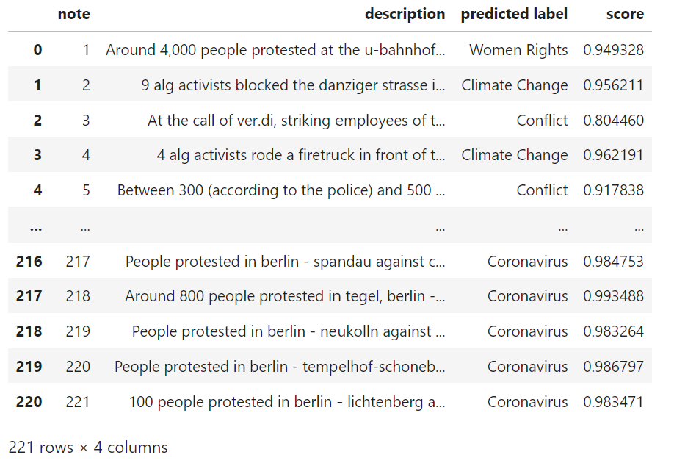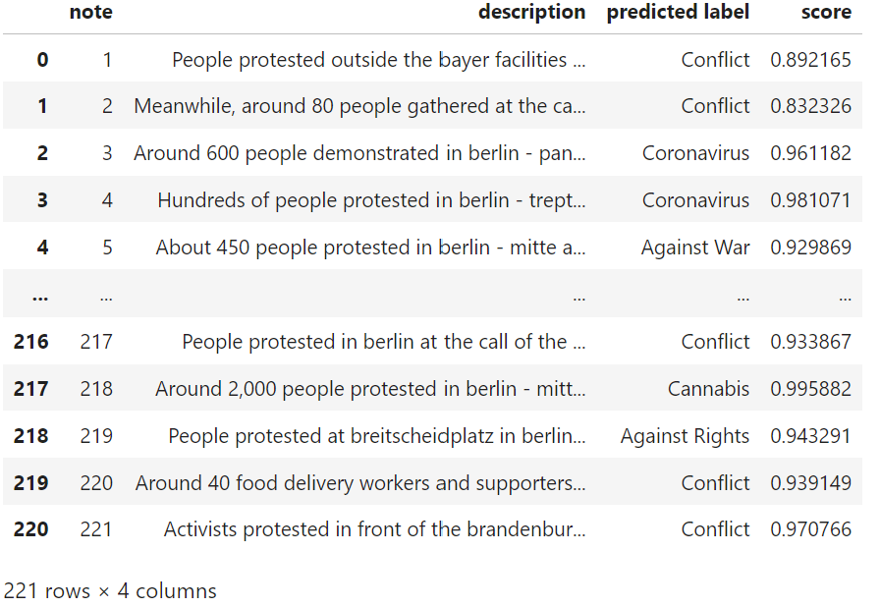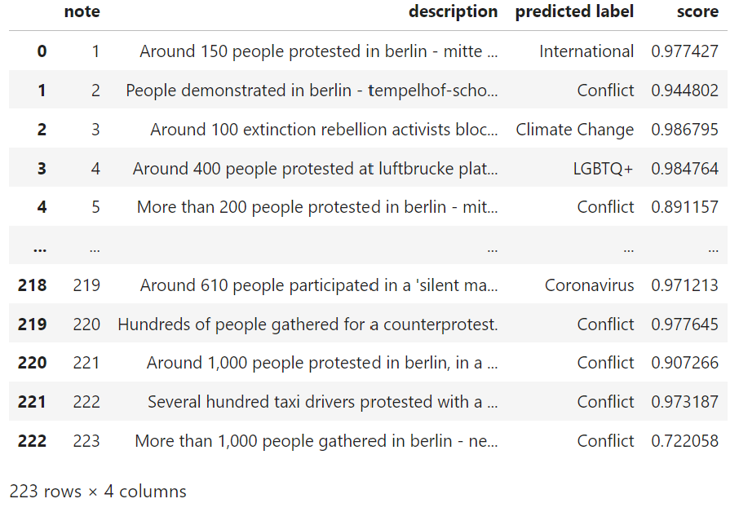

**Findings**

Berlin's protest scene represents a range of societal issues and concerns.

The analysis draws attention to how actively involved the city is in political and social activities.

It is imperative that policymakers, activists, and the general public comprehend these trends.

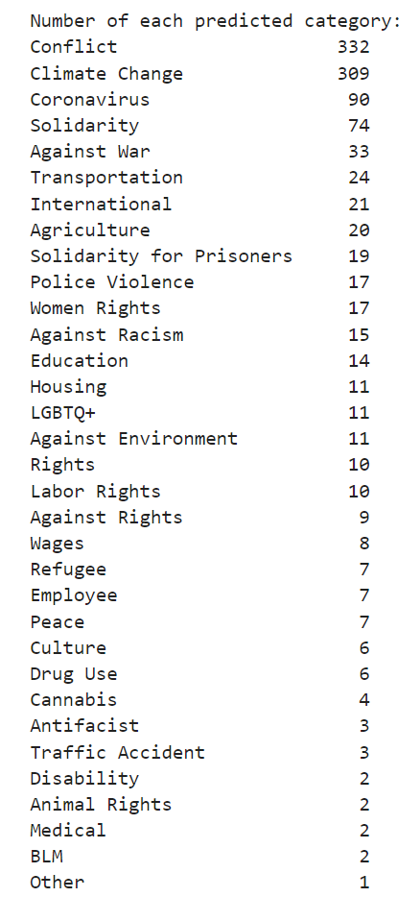

Our work produced important findings. There has been a noteworthy rise in the number of conflict and climate change protests from 2021 to now.

**Accuracy**

With each experiment, our metrics showed improvement, yet the model remained susceptible to change. To enhance accuracy further, we explored the possibility of utilizing even more granular sub-categories, and metric values are seen below.

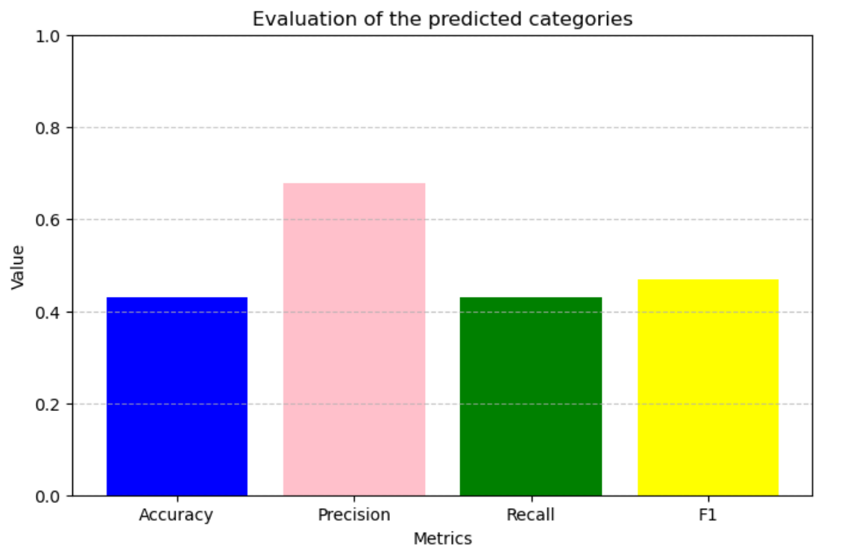

**Conclusion**

"Facebook/bart-large-mnli" and other NLP models are useful resources for examining social phenomena such as protest category classification. The results highlight how crucial it is to continue observing and comprehending Berlin's protest dynamics.

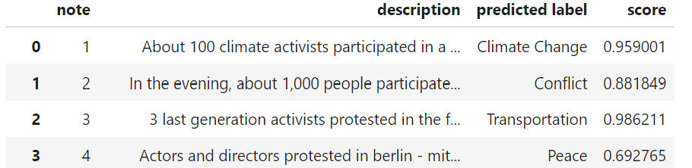

**Challenges**

The main challenge is deciding the categories as target labels. Some of the categories can overlap for a protest. For example, many protest descriptions include multiple categories because of having multiple common. While a protest is about climate change, it can include some words about, agriculture and the economy.

**Future Work**

Model refinement to increase protest classification precision and granularity.